
My Target:
____ /56 or _____% Complete on the day of the test.   (Circle when your test is handed back)

Task One – Introduction to History (Year 7)
In-class Short Answer Response (2.5%)

____ / 56
Name: __________________________

READING TIME – 5 Minutes WORKING TIME – 45 Minutes

Instructions: Read through each question and possible answers. Circle the correct answer.

Section 1 – Multiple Choice (9 marks)

TEACHER MARKING BOX
How many questions did I get right out of 8? _________ /9 marks

1. The time period in history that lasted from 3600 BCE – 500 CE is known as; (1 mark)
- Medieval era
- Ancient Age
- Modern Age
- Paleolithic

2. A ‘source’ is: (1 mark)

- A topping placed on top of food, such as a burger
- A book, statement, person, photo, textbook etc, supplying information
- Any textbook that provides information about the time under study

3. A ‘primary source’ is: (1 mark)

- An item from primary school
- Any evidence that was created during the time period of study
- Any evidence that gives us insight in to the time period of study

4. The ancient age occurred in which continents;
- Asia, Europe and Africa
- North America and South America
- Australia and Antarctica
- Asia, Africa and North America

5. A ‘secondary source’ is: (1 mark)

- An item from secondary school
- Any evidence that was created during the time period of study
- Any evidence that gives us insight in to the time period of study

6. A timeline is: (1 mark)
a) Something to do with clocks
b) A list of events in any order
c) A line displaying key events in chronological order
d) A line displaying key events

7. An example of a written source would be… (1 mark)

a) Ancient Roman coin 41 BCE
b) Tutankhamun’s Mask (ancient Egypt) 1323 BCE
c) An excerpt from a book about ancient Greece published in 2018 CE.
d) Terracotta Warrior (ancient China) 210 BCE

8. A list acknowledging where we got information from is referred to as: (1 mark)

- Biography
- Index
- Bibliography
- Contents

9. The iceman that was discovered in 1991 that was given the name “Otzi” possessed which of the following pieces of evidence;
(1 mark)
- A telephone
- A wheel
- A crossbow
- An axe

Section 2 – Short Responses (47 marks)

1a. List the 8 key concepts of history. (9 marks)

- _________________________________

- Continuity and _______________________

- __________________________ and _________________________

- _________________________________

- _________________________________

- _________________________________

- _________________________________

- __________________________________

1b. Select two key concepts of history from part 1a. Define the key concept and provide an example to support your definition. Your example should be related to the study of history with a particular focus on the Ancient World.

Key concept: _____________________________________ (1 mark)

Definition: (2 marks)
_____________________________________________________________________________

___________________________________________________________________________

Example: (2 marks)
_____________________________________________________________________________

_____________________________________________________________________________

_____________________________________________________________________________

Key concept: _____________________________________ (1 mark)

Definition: (2 marks)
_____________________________________________________________________________

_____________________________________________________________________________

_____________________________________________________________________________

Example: (2 marks)
_____________________________________________________________________________

_____________________________________________________________________________

_____________________________________________________________________________

2. Outline the difference between relative and absolute dating. (3 marks)
_____________________________________________________________________________
_____________________________________________________________________________

_____________________________________________________________________________

_____________________________________________________________________________

_____________________________________________________________________________

3. Explain why the jobs of both a historian and an archaeologist are so important. (6 marks)
_____________________________________________________________________________

_____________________________________________________________________________

_____________________________________________________________________________

_____________________________________________________________________________

_____________________________________________________________________________

_____________________________________________________________________________

_____________________________________________________________________________

_____________________________________________________________________________

_____________________________________________________________________________

_____________________________________________________________________________

_____________________________________________________________________________

_____________________________________________________________________________

_____________________________________________________________________________

4. Identifying and categorising primary and secondary sources. State the word primary or secondary next to each type of source. Watch your spelling! (8 marks)

NAME OF SOURCE | PRIMARY OR SECONDARY SOURCE
The terracotta warriors, found near the burial site of Shi Huangdi in China
“Unlocking the Past”, a history textbook written in 2008
The original diary of Anne Frank who experienced the holocaust in World War 2
Colliers Encyclopedia 2nd Edition

A letter from a World War 1 soldier sent to his family during the Gallipoli campaign.

A painting which is a 21st Century artist’s impression of the Trojan Horse from the Trojan War. The Trojan war was fought between the Ancient Greeks and the Trojans,

The written biography on Cleopatra, published in 1978.

Photographs of ancient Roman Ruins

5. Read carefully through Source 1 below;

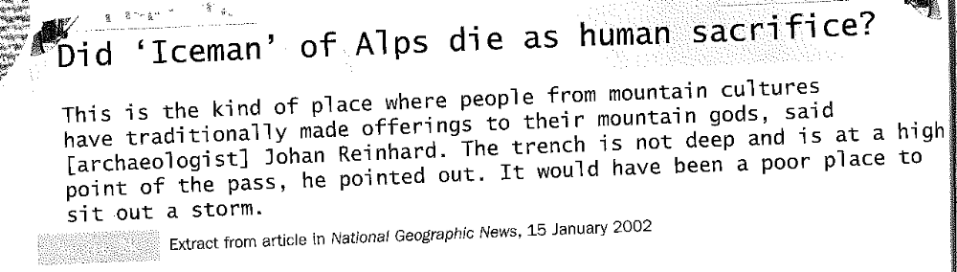

- What is the authors perspective on how Otzi died? (2 marks)
_____________________________________________________________________________

_____________________________________________________________________________

_____________________________________________________________________________

_____________________________________________________________________________

_____________________________________________________________________________

- How could this perspective be contested (argued)? Is there another possible interpretation of the reason for the Iceman’s death? Use clear examples to support your response.
(3 marks)

_____________________________________________________________________________

_____________________________________________________________________________

_____________________________________________________________________________

_____________________________________________________________________________

_____________________________________________________________________________

_____________________________________________________________________________

5. The dates below represent archaeological sites around the world with the age of the remains. Place the information in the correct sequence to create a timeline about Pre-history. Remember to use a scale to represent the years and a heading for your timeline.

(6 marks)
